Structural Mechanics Research

Winter Quarter 2017

The Shooting Method:

The shooting method is a method for approximating a boundary value problem by turning it into an initial value problem. This is done by replacing the boundary constraints and replacing each one with an initial value constraint. The overall number of constraints remains the same, however, a guess must now be made for a previously unspecified initial constraint. Next, using finite difference approximations (1), the solution is stepped through and a resulting endpoint value is calculated. The guess for the initial constraint can be changed until this endpoint value is the desired value.

$U_{i+1}=2U_{i} - U_{i-1} + Δx^{2}\frac{d^{2}U}{dx^{2}}$ (1)

Shooting Method for Bending:

The shooting method was first applied to the bending of a beam due to the application of a uniform load normal to the length, as shown in Figure 1. The governing equation (2) used is also shown below.

*x*

*w*

*u*

*L*

*Figure 1, Uniformly Loaded Beam Bending*

$\frac{d^{4}u}{dx^{4}}=\frac{d^{2}M}{dx^{2}}=\frac{w}{EI}$ (2)

While using equation (2) it is assumed that 1) the applied load, w, is uniformly distributed along the length of the beam, 2) that the material properties E and I are constant and equal to unity, and 3) that the moment is constant and given. However, it would be possible to solve the equation while relaxing one or all of these assumptions.

The process for applying the shooting method to the beam bending problem starts with identifying the boundary values given. In the general case, the boundary values are as follows:

$$u(0) = 0 \frac{d^{2}u(0)}{dx^{2}}=0$$

$u(L) = 0 \frac{d^{2}u(L)}{dx^{2}}=0$

For the examined case, following the above assumptions, the boundary values are reduced to:

$$\frac{d^{2}u(0)}{dx^{2}}=0 \frac{d^{2}u(L)}{dx^{2}}=0$$

The endpoint constraint is then removed and replaced with an initial value constraint with a guessed value such as:

$$\frac{d^{3}u(0)}{dx^{3}}=guess$$

The equation is now an initial value problem with two initial conditions. The approximations are then stepped through by solving the finite difference approximation for a second derivative for the i+1 value, shown in equation (1) above. However, this process cannot be applied to the second point as equation (1) requires the previous two points to be known. To remedy this, the second point is found by utilizing the Taylor Series approximation to give equation (3).

$u(1)=u(0) + \frac{du(0)}{dx}Δx +\frac{1}{2}Δx^{2}\frac{d^{2}u(0)}{dx^{2}}$ (3)

Once the calculations are completed for the first value of the guessed initial condition, the calculations need to be performed again for another guessed value. Using the two endpoint values from these two calculations, the actual slope can be found via linear interpolation, using the guess and the endpoint error as indices. This process is not as simple for the nonlinear case, however, it can still be done using more computationally expensive methods. The results from using the shooting method are shown below in figure 2.

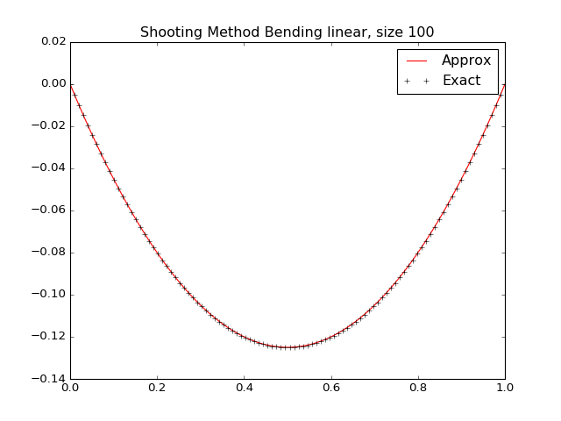

The maximum absolute error, using the shooting method, calculated using 100 points is 8.76 $e^{-15}$ and the interpolated slope guess is -0.5 for the guessed initial condition. The shooting method is advantageous as it requires far less computationally expensive than the finite difference tridiagonal matrix method.

Shooting Method for Buckling:

Applying the shooting method to the buckling of a column is similar to the process for the bending in a beam. Figure 3 shows examined case of a column buckling under a constant point load. The governing equation (4) for this case is also shown below.

*w*

*L*

*y*

*Figure 3, Point Loaded Buckling in a Column*

$\frac{d^{2}u}{dy^{2}}+λu = 0$ (4)

In order to implement the shooting method, the same steps as done for the beam bending must be done. The boundary conditions for the case in Figure 3 are shown below:

$u(0) = 0 u(L) = 0$

The boundary condition at the endpoint is replaced with a guessed initial condition for the slope of the displacement as shown:

$$\frac{du(0)}{dy}=guess$$

Once the boundary conditions are removed and it is turned into a initial value problem, the value of lambda must be addressed. Instead of guessing the initial conditions, the value of lambda will be guessed and the new initial condition will be fixed at one.

$\frac{du(0)}{dy}=1 , λ=guess$

The approximations will be stepped through using the finite difference approximation in equation (1) and applying the solution derived from the Taylor’s Series given in equation (3) to the second point.

Once the calculations have been made for a guessed value of lambda, it is repeated for a different guessed value. These two guesses and the resulting endpoint values are then linearly interpolated in order to produce an approximate value for lambda and the corresponding approximate solution. This method will only work if there is a general idea of the value of lambda is, so instead a more general method was used. The value of guessed lambda was increased in small steps until the error at the endpoint was minimized. The lambda corresponding to the minimal error was used as the guessed lambda. Although this method is more computationally expensive, it can work for nonlinear cases. The results from the application of the shooting method, compared to a scaled exact solution, are shown below in Figure 4.

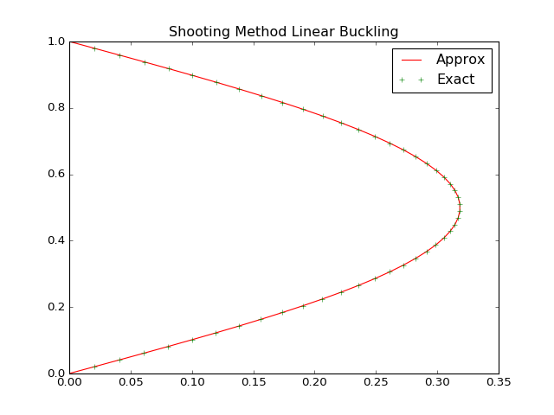

*Figure 4, Results of Shooting Method for Buckling*